ACTIVITIES

5. BYZANTIUM, THE ROMAN EMPIRE IN THE EAST
- Differentiate Byzantium, Constantinople and Istambul.
- Byzantium: first Greek town. The name of the Byzantine Empire comes from this name.
- Constantinople: In 330, the Roman Emperor Constantine changed the name of the town for Constantinople. From 395 it was chosen the capital of the Eastern Roman Empire.
- Istambul: Name of the city since the Turks conquered it in 1453.

- Date the main events of the Byzantine Empire:
  - Beginning: 395 (division of the Empire) or 476 (fall of Western Roman Empire).
  - Reign of Justinian I (1st Golden Age): 527-565 (6th century)
  - Loss of Justinian conquests: 7th and 8th centuries.
  - Hellenization: from the 6th to the 8th century
  - Second Golden Age: 9th and 10th
  - Decline of the Empire: from the 11th to the 15th century (year 1453)
  - End of Byzantium (conquered by the Turks): 1453

- Who was Justinian I? Why is he important? (Explain both reasons.)
He was the Byzantine/ Eastern Roman Emperor (527-565).
- He tried to conquer the provinces of the former Western Roman Empire (Italy, Balearic Islands, North Africa and South of Hispania).
- He compiled all the traditional Roman laws in the Justinian Code.

- What is “to hellenise”? Why do you think it happened?
- To adopt cultural and political practices and the language of Greece. They stopped speaking Latin, and Greek became official.
- Because Greek had a big influence in the East of the Mediterranean Sea and it was an important language for culture in the Roman Empire.

- What’s a “basileus”?
Emperor in Greek language.
- Differences between Orthodox and Catholicism:
Catholicism | Orthodox
Christians from the territories of the ancient Western Roman Empire.  Their leader was the Pope (bishop of Rome).  Different ceremonies, rituals and thoughts. | Christians from the East (Byzantine Empire).  Byzantine Emperor (who ruled over many bishops).  Different ceremonies, rituals and thoughts.

- Main characteristics of the Byzantine art.
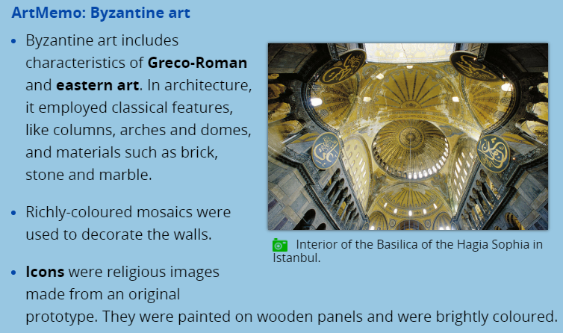
- Which is the most famous building of the Byzantine Empire?
It is a Christian basilica /a church /a cathedral in Constantinople. It was started in the 4th century and rebuilt in the 6th by Justinian I.
- Look for a picture of Hagia Sophia, a Byzantine icon and a mosaic from Ravenna. Print, glue and label them (name, place, date… when possible).
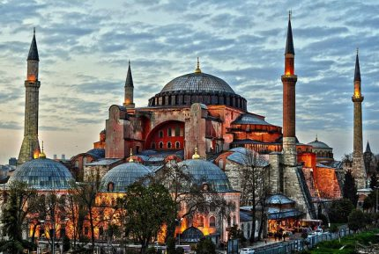 Church of Hagia Sophia, 4th- 6th centuries, Constantinople.
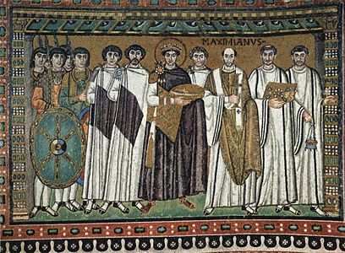 Mosaic of Justinian I in San Vitale in Ravenna, 6th century.
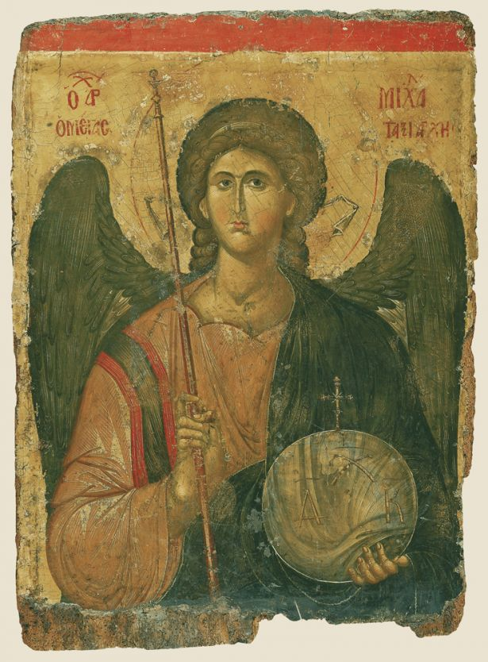 Icon of Archangel Michael, 14th Century, Constantinople (nowadays at Byzantine and Christian Museum in Athens).

